|  |  |  |  |  |  |  |  |  |  |  |  |  |  |  |
| --- | --- | --- | --- | --- | --- | --- | --- | --- | --- | --- | --- | --- | --- | --- |
| **Montgomery Street School**  **Mission Statement**  **M**aximize all children’s potential, academically, Physically, and socially while  **S**triving to guide and enrich students to help them reach and  **S**ustain a positive self-image, within a safe, secure environment | Beaver MascotMontgomery Street School    **FEBRUARY**  **NEWSLETTER**  **2019**  [montgomerystreet.nbed.nb.ca/](http://beaverbrook.nbed.nb.ca/)  *692 Montgomery Street, NB E3B 2X8*  *Phone 506 453-5433 Fax 506 457-7344*  *Principal: K. Stiles Vice-Principal: J. O’Rourke-Miller* | **SCHOOL HOURS**   |  |  | | --- | --- | | 7:50 | Drop off | | 8:10  8:20 | First Bell  Classes Begin | | 10 :20:-10:40 | Beaver MascotRecess | | 12:15 - 12:55 | Lunch | | 2:00  2:50 | Dismissal Grades K – 2  Dismissal Grades 3 - 5 | | 12:00 Noon | Wed. Dismissal Gr. K – 5 |   Students are considered late for school  at 8:20 am. |

|  |  |  |  |  |
| --- | --- | --- | --- | --- |
|  |  |  |  | *1*  **FOOD DRIVE Feb. 1-14**  **Choir performs**  **1:00PM** |
| 4  **-Code Mobile**  -  H & S Meeting  7:30 pm  -1st Ukulele Club day  -Student Leadership  3-4pm | 5  Chinese New Year 2019  Pizza Day if ordered | 6  Pink Shirt Orders Due | 7  Bagel Day if ordered    Skipping Club members -bring your ropes! | 8  Popcorn $1.00 due by 8:30 |
| 11  **Visiting Author**  **Jenny McGrath**  Feb. 11 – 15 Staff Appreciation Week | 12  Pizza Day if ordered | 13  Deserves Praise Assembly  9:50 | 14  **HAPPY VALENTINES DAY♥**  -Vegetable Treats  -Food Drive Ends  -Skipping Club members- bring your ropes  -Bagel Day if ordered | 15  Popcorn $1.00 due by 8:30  GLOW STICK DANCE PARTY 6:00 - 7:30 |
| 18  **FAMILY DAY NO SCHOOL** | 19  Pizza Day if ordered  Storm date for Author Visit | 20 | 21  Bagel Day if ordered  Skipping Club members- bring your ropes | 22  Popcorn $1.00 due by 8:30  **DAY 100!** |
| 25  -Gr. 3 & 4 FI classes visit the Legislature  -Student Leadership  3-4 pm  -PSSC Mtg. 4-5:15  **HAT DAY** | *26*    Pizza Day if ordered  **SCHOOL COLORS DAY** | 27  **WEAR PINK**  Banana Treats | 28  -Skipping Club members- bring your ropes  **-BLACK HISTORY MONTH –**  **- PRESENTATIONS Gr. 3 – 5**  **-GUM DAY** | **JERSEY DAY** |

Calling the **SNOW LINE: 453-5454 OR 1 888 388-4455**

or checking Anglophone West School District (http://web1.nbed.nb.ca/sites/ASD-W/Pages/default.aspx) will give your access to information regarding district or regional school closures and late or cancelled buses. We are **ZONE 6.**

**Visiting Author Jennifer McGrath** - Montgomery Street School is pleased to have a visiting author in our school on **Monday, Feb. 11th.**  There will be various workshops at the different grade levels happening throughout the day.

An award-winning children's author from New Brunswick, Jennifer has written two middle-school adventure novels, and two picture books. She is currently at work on a number of other creative projects. An enthusiastic and animated workshop presenter, Jennifer is a popular visitor to school classrooms.

Jennifer studied English at St. Francis Xavier University in Antigonish, Nova Scotia before going on to earn an MA in English Literature with a Directed Study in Children's Literature from the University of Victoria in British Columbia.  Jennifer lives in Moncton, NB.  She loves animals, books, music, movies, theatre, story-telling, costumes, jokes, and, of course…chocolate!

**RESILIENCY TIP # 2**

**BUILD A STRONG EMOTIONAL CONNECTION**

Spend one-on-one time with your kids. Kids develop coping skills within the context of caring relationships. When kids know they have the unconditional support of a parent, they feel empowered to seek guidance and make attempts to work through difficult situations. Positive connections allow adults to model coping and problem-solving skills to children

****Pink Shirt Day will be celebrated on **February 27th**. Pink represents our support against negative behavior. Together we can make a difference. Remember everyone deserves respect and no one deserves to be bullied. An order form will go home for anyone wanting to order a pink shirt if your child does not have one from previous years. Due back Feb. 6th.

**Wear Pink on February 27th to show your support.**

**Montgomery Annual Food** Drive – *Feb. 1st – 14th*

Each year students make a donation to the Food Bank. Due to the storm day we were not able to sell out Christmas shopping items to donate money. This year we will do a drive instead where students bring in non-perishable items to be donated. These items can be dropped off at the table in front of the office from Feb. 1 – Feb. 14th.

**PHYSICAL EDUCATION**

***INTRAMURALS***: Floor Hockey

Grades 2 & 3 and Grades 4 & 5

**CODE MOBILE**

N. B .and PEI with Canada Learning Code, a not-for-profit organization that promotes diversity in the tech industry and provides technical education for our youth. MSS will have [Code Mobile](https://www.canadalearningcode.ca/code-mobile/) at the school on **Monday Feb. 4**th for a fun and exciting technical experience.

**VENDING MACHINE**

Due to the changes in the nutrition policy there is now a new variety of items that may be appealing to your child but still have nutritional value. For those interested Chocolate Milk is available in the vending machine.

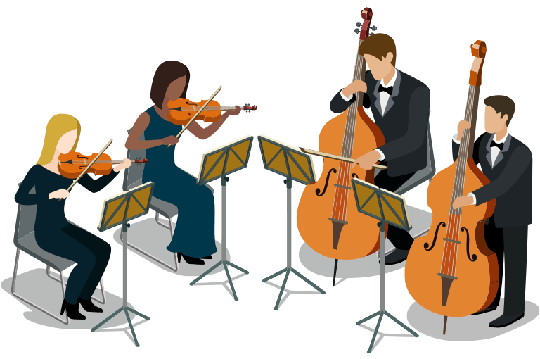**MUSIC**

Students were very receptive and had great questions when the UNB String Orchestra students visited on Jan. 29th.

***All part of music education at MSS!***

**REMINDERS:**

* Please remember to send in your child’s **STUDENT DATA FORM** back to your child’s teacher so we have up to date information on your child. Make sure the form is signed and dated. THANKS Mrs. Gilchrist

MC900232112[1]**NO SNOWBALLS**

Students can be hurt badly if they are hit with a snowball.   Please discuss the reasons for this with your child so they understand why these items cannot be thrown.

**COLDER WEATHER**

****The colder weather is here. Please make sure your child has a winter coat, snow pants, mittens and a hat for outside playtime at recess and lunch each day. We go outside when it is under -20C. We notice many students without snow pants first thing in the morning.

**WINTER HATS AND MITTENS**

***Thank you to everyone who filled our bucket!***

**LOST and** FOUND

**Please check the red lost and found bins in the front lobby when visiting the school.**

**HOME and SCHOOL NEWS**

Thank you to all families who supported the book drive to help build a library for MSS students.

A H & S Meeting will be Monday Feb. 4th at 7:30 pm

**MILK**

Last day for term 2 milk order is March 1. A notice will go home in Feb. to cover March to June.

**WINTER CARNIVAL FUN**

Mon. Feb. 25th – **HAT DAY** – be creative!

Tues. Feb. 26th – **SCHOOL COLORS DAY** (red & blue)

Wed. Feb. 27th – **PINK SHIRT DAY**

Thurs. Feb. 28th – **GUM DAY** – yes, you can chew gum!

Fri. Mar. 1st – **JERSEY DAY –** Choose your favorite team

**POPCORN FUNDRAISER**

Popcorn is for sale each Friday for $1.00 Please send money in with your child each week before 8:30 am. Thank you for your support.

**SCHOOL WEBSITE**

Please visit the school website at *montgomerystreet.nbed.nb.ca*

We will be posting our school newsletter each month under the newsletter section and keeping you up to date on all the current activities at the school.

**CUSTODIAN MESSAGE**

Mr. Claybourn would like to thank all the students who participated in the cleanest classroom award.

**DAY 100**

Day 100 is celebrated with a variety of activities happening in some of the classrooms on Feb. 22nd.

**LOOKING AHEAD**

March 4 – 8 March Break NO SCHOOL

March 22 – **NO SCHOOL**

(Parent teacher meetings AM /Prof. Learning Day PM)

March 29 – Gr. 3-5 Mary Poppins Jr. Production